

Algorithms Fundamentals

“Stages of program compilation and Levels of programming”

Student: Humberto Hernández De La Cruz

Group:Data 1A

Introduction

In this work we are going to see two things the first it is the Stages of program compilation, these are six stages and we are to let’s see what these consist of. The other thing that we are talk is about the levels of programming the uses of these and what they are.

Stages of program compilation

There are six stages of program

**1.Lexical Analysis:** The comments and unnecessary spaces are removed

-The keywords, constants and identifiers are replaced by the tokens, the tokens are symbolic strings these serve to identify what the elements are.

**2.Symbol table construction:** A table stores names and addresses all variables, constants and arrays.

-The variables are checked to make sure that these have been declared and determine the data types that were used.

**3. Syntax Analysis:** Tokens are checked to know if they match the syntax of the programming language.

-The error messages are produced, If the syntax had an error.

**4.Semantic Analysis:** In this they check 2 things variables and operations, variables are checked to make sure that they have been declared and contain the correct data type and the operations checks if the type of variable that is being used is appropriate.

**5.Code generation:** The machine code is generated.

**6.Optimisation:** The optimization of the code helps the program to be more efficient to runs faster and uses fewer resources.

[Stages of compilation - Program construction - Eduqas - GCSE Computer Science Revision - Eduqas - BBC Bitesize](https://www.bbc.co.uk/bitesize/guides/zmthsrd/revision/3)

Levels of programming

In this part we got 3 levels of programming the machine languages, assembly languages and high-level languages.

**The machine languages** use the binary patterns that is conformed by 0 and 1 these binary patterns represent simple operations that can be accomplished by the computer, the machine language programs are executable this means that they can be run directly, to use this program form requires to memorize the binary codes and this can be difficult for the human.

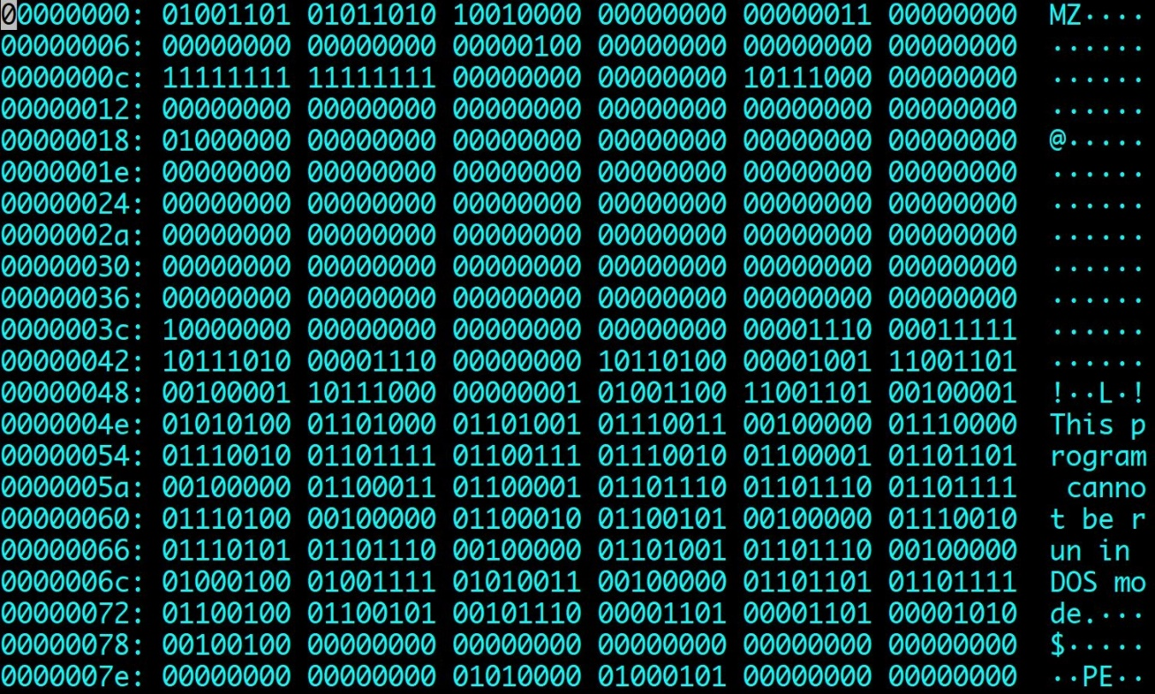

**Assembly languages** are an effort to make the programming easier for the human. Replace the machine language with simple pneumonic abbreviations. This assembly language is only for a specific computer. The assembly language program needs to be translated to the machine language the program that make this job is knowed by the name of assembler.

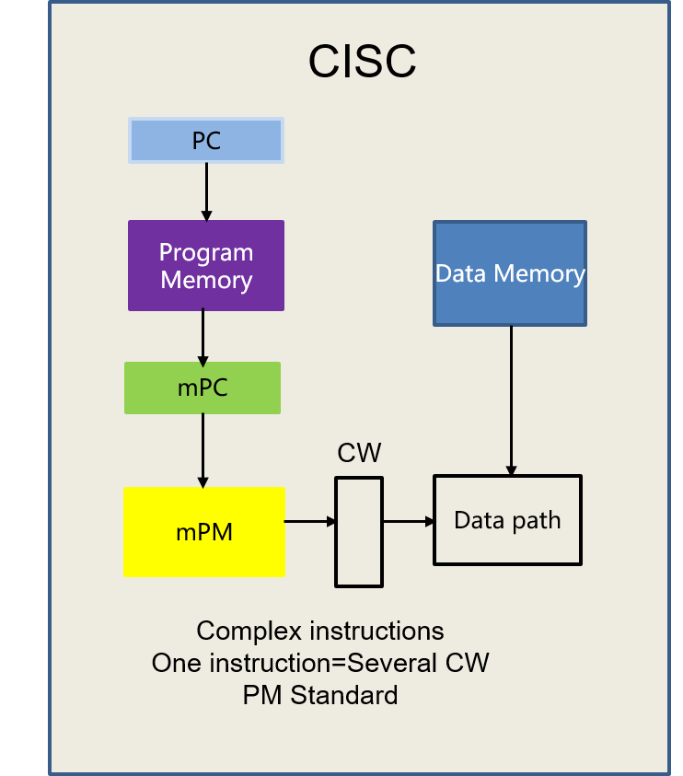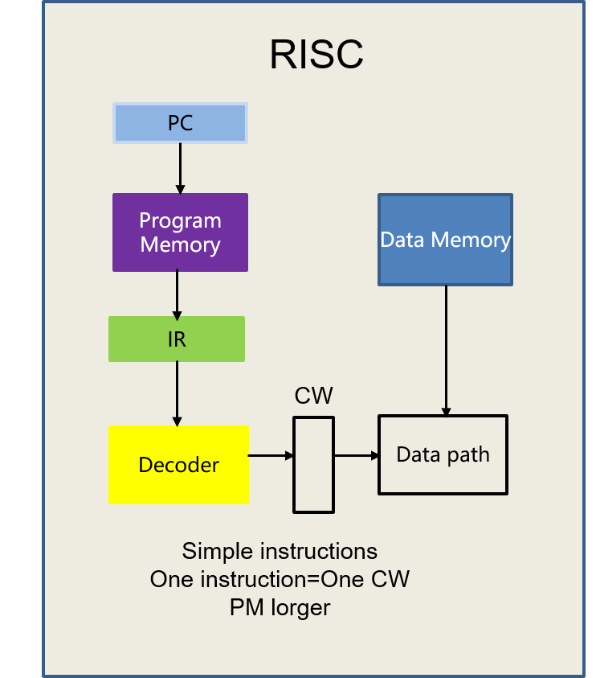

**The high-level languages** is the easiest way to programmers to think in the programming language, this language require the translation to machine language before execution, the translation is worked by a compiler or an interpreter.

The compilers translate the entire source code program before execution.

Interpreters translate source code programs one line at time.



[Levels of Programming Languages. Know the menu before you order the… | by Mohit Chawla | The Bit Theories](https://thebittheories.com/levels-of-programming-languages-b6a38a68c0f2)